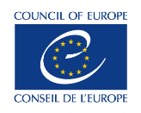
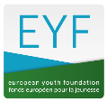
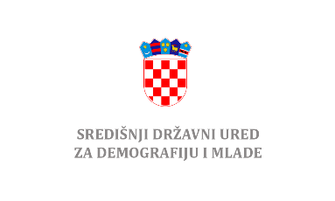

Introduction to the Council of Europe’s resources and EYF grants for youth organisations in Republic of Croatia

Training session organised in co-operation with
Central State Office for Demography and Youth in Republic of Croatia

17 – 19 May 2022, 9.00 – 13.00 (online)

Day 1, 17 May 2022
9.00 Opening of the session and official welcome
Technical information
Introduction to the session objectives and schedule

9.30 Getting to know each other in the group and expectations
Interactive session to introduce participants and their organisations and identify participants’ expectations.

10.00 Introduction to the Council of Europe
Interactive session to inform and learn about the Council of Europe and its Youth sector specifically

10.30 Linking my organisation with the Council of Europe youth sector’s priorities
An interactive session in 2 phases, including work in groups to allow participants reflect on their organisations’ work and possible links with the Council of Europe’s youth sector priorities (Revitalizing pluralistic democracy; Access to rights; Peaceful and inclusive societies; Youth work).

11.00 Break

11.30 Linking my organisation with the Council of Europe youth sector’s priorities (continuation)

12.00 Introduction to the European Youth foundation (EYF)
Presentation of the EYF, questions and answers

13.00 End of session
Day 2, 18 May 2022
9.00 Opening of the session and feedback from Day 1
9.15 Project management: practical exercises
Interactive session on the project management cycle; practical exercises, with a focus on key issues in EYF-supported projects:
- Identifying needs
- Young people at the centre of the project
- How to define objectives in a smart way
- How to define activities
- Non-formal education
- How to evaluate success
- Gender and inclusion
- Visibility
- Adaptations in a project
- Reporting
11.00 Break
11.30 Project management (continuation)
13.00 End of session
Day 3, 19 May 2022
9.00 Back to cooperation with the EYF: NGO registrations and EYF grants
- Registration process: step-by-step
- Grant application forms
- Granting process
11.00 Break
11.30 Next steps
- My project ideas: brainstorming
- My open questions
12.30 Evaluation of the session
13.00 End and official closing

